

**HTML Assignment - Extended**

**Objective:** This assignment aims to assess your understanding of the basic HTML, CSS, Javascript and jQuery concepts.

**Implementing Dynamic Content Loading**

You are building a simple website that displays a list of blog posts. Your task is to implement dynamic content loading using AJAX and jQuery. When a user clicks on a "Load More" button, the next set of blog posts should be fetched from the server and displayed without refreshing the page.

Instructions:

Create an HTML file with the following structure:

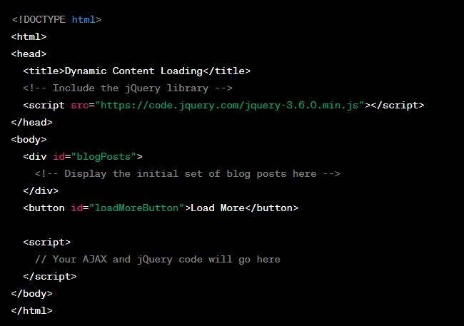

1. In the **<div id="blogPosts">**, display a few initial blog posts fetched from the server. You can use static content or placeholder text for this practice. The goal is to load additional blog posts dynamically when the "Load More" button is clicked.
2. Write AJAX code to fetch the next set of blog posts from the server. Assume that the server endpoint to retrieve blog posts is https://jsonplaceholder.typicode.com/posts. The server will respond with JSON data containing an array of blog post objects.
3. Use jQuery to handle the click event on the "Load More" button. When the button is clicked, your AJAX code should be triggered to fetch the next set of blog posts.
4. Upon receiving the data from the server, dynamically add the new blog posts to the <div id="blogPosts"> section without refreshing the page. Each blog post should be displayed as a separate card or list item.

Bonus (Optional):

* Implement pagination by fetching a specific number of blog posts per request and adding a "Next" button to load the next page of blog posts.
* Add loading spinners or animations to indicate that new content is being fetched from the server.
* Handle error scenarios, such as server-side errors or no more blog posts to load.